SRI8610C Gas Chromatograph SHUTDOWN Procedure

1. Stop the PeakSimple software from operating the GC. Click the Run 1 button, and it should change from a bottom green light to a middle yellow light. Any operation on the GC should be aborted and nothing should be running / cycling.

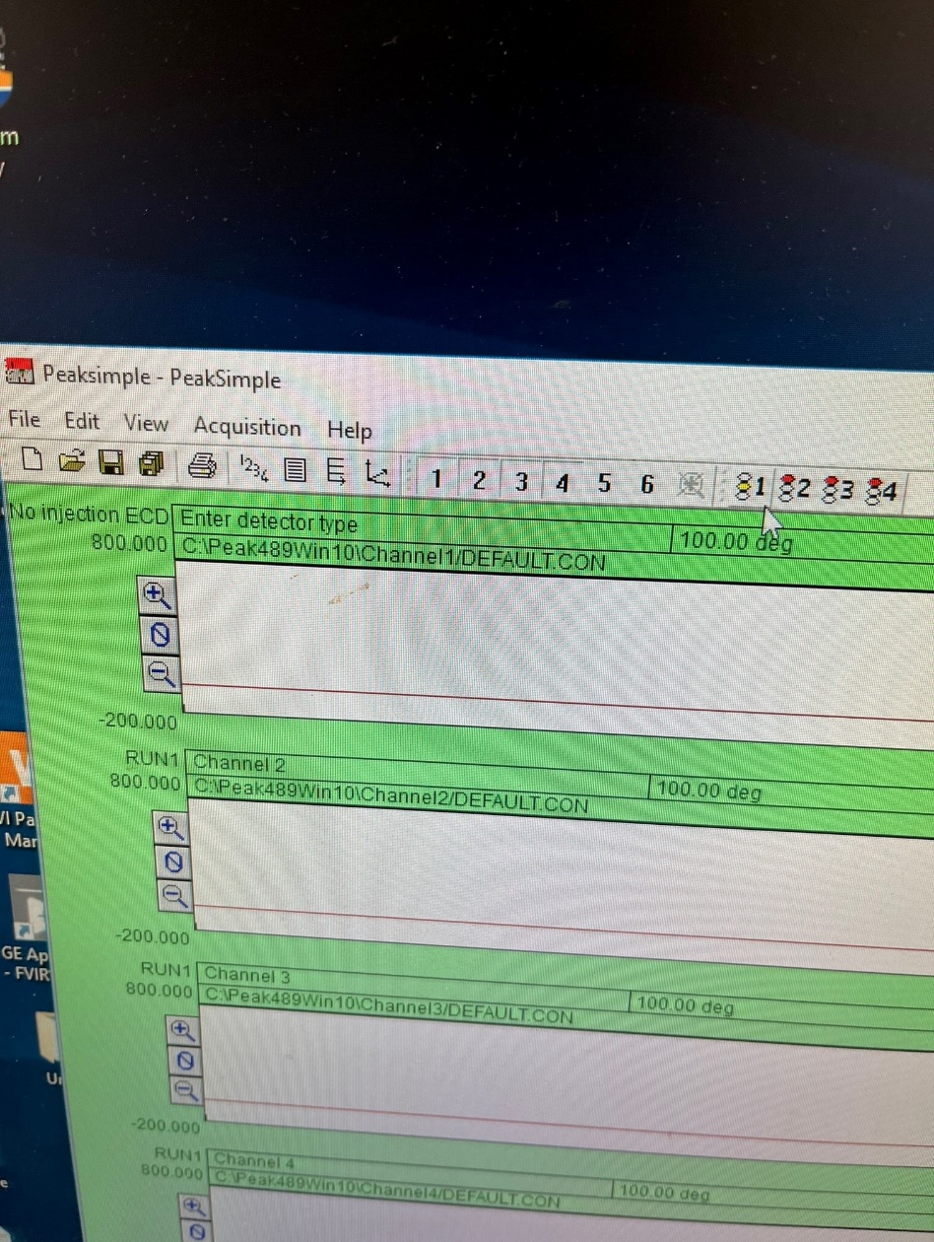

**Idle, not running**

1. Close the PeakSimple software. If asked to save all, click No.

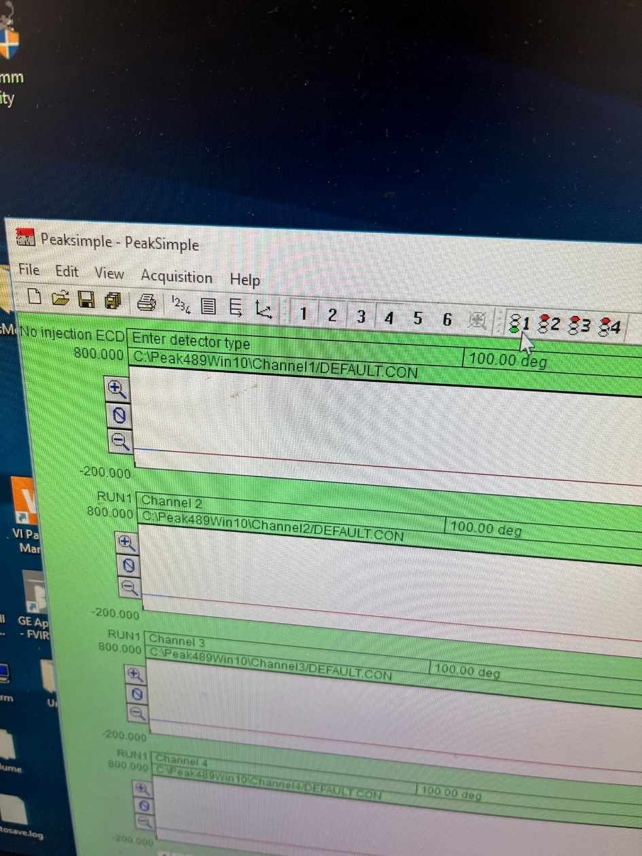

**Running**

1. Turn off the SRI8610C Gas Chromatograph (3A). Be careful, it may be warm / hot. A picture containing text, electronics

   Description automatically generated

**3A**

1. A picture containing text, indoor, cluttered

   Description automatically generatedClose the SRI Model H2-100 Hydrogen Generator output valve (4A), and switch the power off (4B).

**4B**

**4A**